Algorithms & Data Structures
Excercise-7

Code:

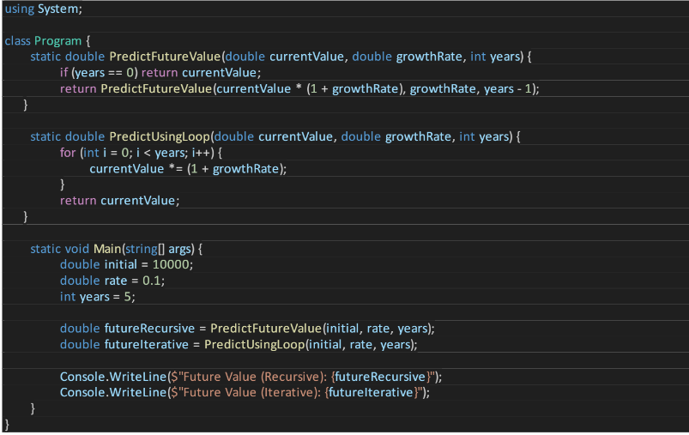

Output: 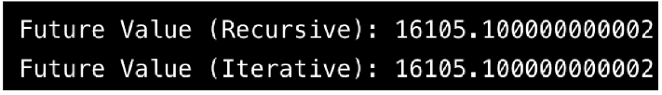

Analysis:

- · Recursive: O(n) time, O(n) space (stack)
- · Optimized (iterative): O(n) time, O(1) space
- . Use loops or memoization to reduce stack overhead.

